Spark study notes: core concepts visualized

<https://blog.usejournal.com/spark-study-notes-core-concepts-visualized-5256c44e4090>

Learning Spark is not an easy thing for a person with less background knowledge on distributed systems. Even though I have been using Spark for quite some time, I find it time-consuming to get a comprehensive grasp of all the core concepts in Spark. The [official Spark documentation](https://spark.apache.org/docs/latest/?source=post_page---------------------------) provides a very detailed explanation, yet it focuses more on the practical programming side. Also, tons of online tutorials can be overwhelming to a starter. Therefore in this article I would like to note down those Spark **core concepts,**but in a more visualized way. Hope you will find it useful as well!

Note: probably you already have some knowledge about Hadoop, so I will skip explanations on trivial things such as nodes and clusters.

## Spark architecture and deploy modes

To put it simple, Spark runs on a master-worker architecture, a typical type of parallel task computing model. When running Spark, there are a few modes we can choose from, i.e. local (master, executor, driver are all in the same single JVM machine), standalone, YARN and Mesos. Here we only talk about Spark on YARN and the difference between YARN client and YARN cluster since both are most commonly used, yet very confusing.

Below two pictures illustrate the setup for both modes. They look quite similar, don’t they? However, by looking at the orange highlighted part you will probably notice the minor difference, which is the location of Spark driver program. This is basically the only difference between the two modes.

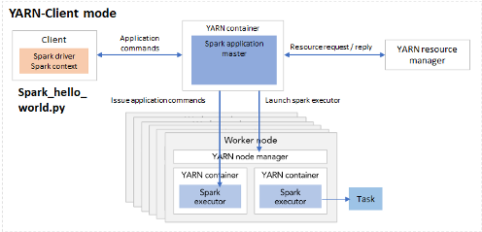

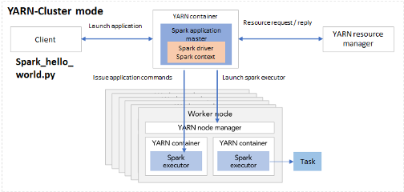

Fig 1. Spark deployment mode YARN-client (left) and YARN-cluster (right)

Suppose you’ve written a Spark application called spark_hello_world.py. In client mode, when executing the python file using spark-submit, the driver is launched directly within the spark-submit process, hence it will reside in the same machine as with spark_hello_world.py. When initializing the Spark context, the driver within the local machine will connect to the application master in the cluster. Starting from the master, Spark launch more executors.

In cluster mode, the spark_hello_world.py code lives in the client machine and the client machine is outside of the cluster. When executing the application python code, it launches a driver program in one of the nodes in the cluster. Together with Spark application master it can launch executors and issue application commands.

Given that the setup do not differ much, you must be wondering why we need two different modes. In practice, this relates to whether the client machine is physically co-located with the worker machines or not. If the client machine is “far” from the worker nodes, e.g. you write the spark_hello_world.py on your laptop but the workers are AWS EC2 instances, then it makes sense to use cluster mode, so as to minimize network latency between the drivers and the executors. In another scenario, if your python file is in a gateway machine quite “close” to the worker nodes, the client mode could be a good choice.

[[](https://blog.usejournal.com/meet-journal-d222fce8db1d)](https://blog.usejournal.com/meet-journal-d222fce8db1d)

## Executors

Now that we understand the Spark cluster setup, let’s zoom in to one of the most important elements in Spark - executor. Executors are the processes that run tasks and keep data in memory or disk storage across them.

When going through the Spark documentation you might be surprised at the number of configurable parameters related to executors. Instead of trying hard to figure out the relation between several parameters in one’s head again and again, let’s look at it visually.

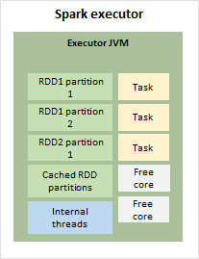

Fig 2. Spark executor internals

As shown in Figure 2, in each executor there is an executor JVM, storing the RDD partitions, cached RDD partition, running internal threads and tasks. If there are more cores than required by the tasks, there would also be free cores in the JVM. This green block of executor JVM will be our starting point to look at the memory management in executors.

## Executor memory management

In the executor container, there are mainly two blocks of memory allocated: memory overhead and executor memory.

Memory overhead is reserved off-heap memory for things like VM overheads, interned strings, other native overheads, etc.. By caching data outside of main Java heap space, but still in RAM, the off-heap memory allows the cache to overcome lengthy JVM Garbage Collection pauses when working with large heap sizes.

Executor memory consists of three parts as follows.

* Reserved memory
* User memory: for storing things such as user data structures and internal metadata in Spark.
* Storage and execution memory: for storing all the RDD partitions and allocating run-time memory for tasks.

Figure 3 shows the relevant parameters for each memory block. Suppose we set spark.executor.memory to 4 GB, then Spark will request 4.4 GB memory in total from the resource manager. Out of the 4 GB executor memory, we actually get 3.7 GB because the rest is reserved. And by default, we get 2.2 GB (0.6 * 3.7) as execution + storage memory. Out of this, 1.1 GB will be used for storage such as storing RDDs, and the rest will be execution memory.

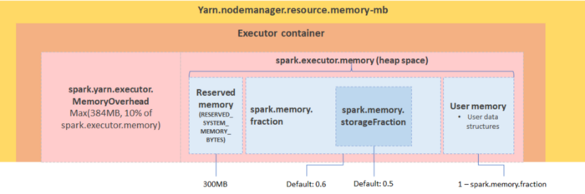

Fig 3. Spark executor memory decomposition

## RDD, jobs, stages and tasks

If you have already started debugging Spark application using Spark UI, then probably keywords like jobs, stages and tasks sound familiar. So how are they relevant with RDDs?

We know that there are two operations on RDDs, transformations (e.g. filter, union, distinct, intersection) by which a new RDD is produced from the existing one virtually without actual execution, and actions (e.g. take, show, collect, foreach) which triggers the execution. When transforming an RDD, based on the relationship between the parent RDD and the transformed RDD, the dependency can be narrow or wide. With narrow dependency, in the parent RDD one or many partition will be mapped to one partition in the new RDD. While with wide dependency, such as when doing a join or sortBy, we need to shuffle partitions in order to compute the new RDD.

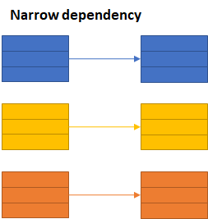

Fig 4–1. narrow dependency in RDD transformation

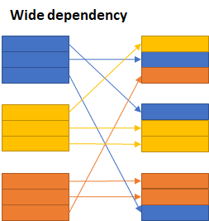

Fig 4–2. Wide dependency in RDD transformation

The jobs, stages and tasks are therefore determined by the type of operations and the type of transformations. A job is created when there is an action on an RDD. Within the job, there could be multiple stages, depending on whether or not we need to perform a wide transformation (i.e. shuffles). In each stage there can be one or multiple transformations, mapped to tasks in each executor.

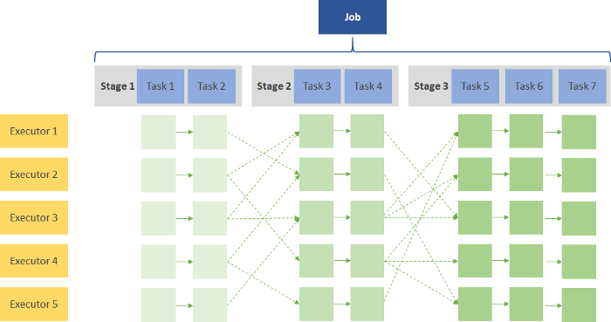

Fig 5. Illustration of one Spark job

To understand it practically let’s look at the following simple code snippet.

1. val RDD1 = sc.parallelize(Array('1', '2', '3', '4', '5')).map{ x => val xi = x.toInt; (xi, xi+1) }  
2. val RDD2 = sc.parallelize(Array('1', '2', '3', '4', '5')).map{ x => val xi = x.toInt; (xi, xi*10) }  
3. val joinedData = RDD2.join(RDD1)  
4. val filteredRDD = joinedData.filter{case (k, v) => k % 2 == 0}  
5. val resultRDD = filteredRDD.mapPartitions{ iter => iter.map{ case (k, (v1, v2) ) => (k, v1+v2) } }  
6. resultRDD.take(2)

There are a few operations in this code, i.e. map, join, filter, mapPartitions and take. When creating the RDDs Spark will generate two stages for RDD1 and RDD2 separately, as shown in stage 0 and 1. Since map function contains a narrow dependency, the mapped RDDs will also be included in stage 0 and 1 respectively. Then we join RDD1 and RDD2, because join is a wide transformation containing shuffles, Spark creates another stage for this operation. Afterwards, filter and mapPartition are again a narrow transformations in stage 2, and by calling take (which is an action), we trigger Spark’s execution.

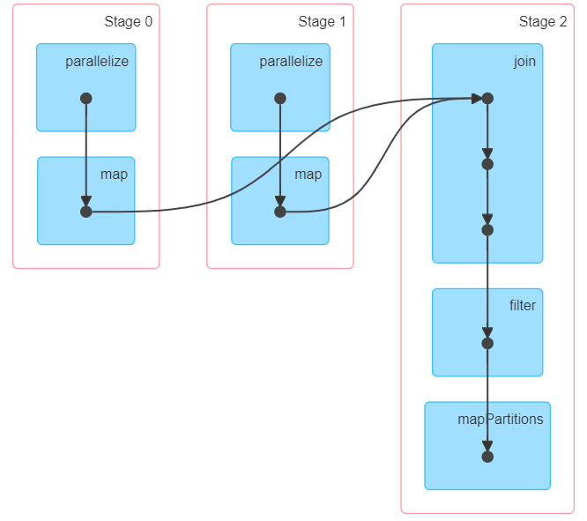

Fig 6. DAG visualization

So, that is all the basic stuff for Spark. Hope after reading this article these concepts are more clear for you. Happy learning!

## References

* [https://spark.apache.org/docs/latest/](https://spark.apache.org/docs/latest/?source=post_page---------------------------)
* [https://spoddutur.github.io/spark-notes/distribution_of_executors_cores_and_memory_for_spark_application.html](https://spoddutur.github.io/spark-notes/distribution_of_executors_cores_and_memory_for_spark_application.html?source=post_page---------------------------)​
* [https://0x0fff.com/spark-memory-management/](https://0x0fff.com/spark-memory-management/?source=post_page---------------------------)​
* [https://www.pgs-soft.com/blog/spark-memory-management-part-1-push-it-to-the-limits/](https://www.pgs-soft.com/blog/spark-memory-management-part-1-push-it-to-the-limits/?source=post_page---------------------------)​
* [https://spark.apache.org/docs/latest/rdd-programming-guide.html#rdd-operations](https://spark.apache.org/docs/latest/rdd-programming-guide.html?source=post_page---------------------------#rdd-operations)​

**Any feedback and comments are welcome. Your support means a lot to an author! ❤**

Connect with me on [LinkedIn](https://www.linkedin.com/in/xin-pang/?source=post_page---------------------------).

[[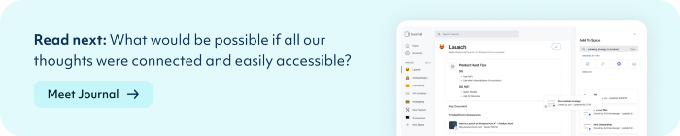](https://usejournal.com/?utm_source=medium.com&utm_medium=noteworthy_blog&utm_campaign=guest_post_image)](https://usejournal.com/?utm_source=medium.com&utm_medium=noteworthy_blog&utm_campaign=guest_post_image)

📝 Read this story later in [Journal](https://usejournal.com/?utm_source=medium.com&utm_medium=noteworthy_blog&utm_campaign=guest_post_read_later_text&source=post_page---------------------------).

🗞 Wake up every Sunday morning to the week’s most noteworthy Tech stories, opinions, and news waiting in your inbox: [Get the noteworthy newsletter >](https://usejournal.com/newsletter/?utm_source=medium.com&utm_medium=noteworthy_blog&utm_campaign=guest_post_text&source=post_page---------------------------)

# Running Spark Jobs on YARN

<https://medium.com/@goyalsaurabh66/running-spark-jobs-on-yarn-809163fc57e2>

When running Spark on YARN, each Spark executor runs as a YARN container. Where MapReduce schedules a container and fires up a JVM for each task, Spark hosts multiple tasks within the same container. This approach enables several orders of magnitude faster task startup time.

Spark supports two modes for running on YARN, “yarn-cluster” mode and “yarn-client” mode. Broadly, yarn-cluster mode makes sense for production jobs, while yarn-client mode makes sense for interactive and debugging uses where you want to see your application’s output immediately.

Understanding the difference requires an understanding of YARN’s *Application Master* concept. In YARN, each application instance has an Application Master process, which is the first container started for that application. The application is responsible for requesting resources from the ResourceManager, and, when allocated them, telling NodeManagers to start containers on its behalf. Application Masters obviate the need for an active client — the process starting the application can go away and coordination continues from a process managed by YARN running on the cluster.

In yarn-cluster mode, the driver runs in the Application Master. This means that the same process is responsible for both driving the application and requesting resources from YARN, and this process runs inside a YARN container. The client that starts the app doesn’t need to stick around for its entire lifetime.

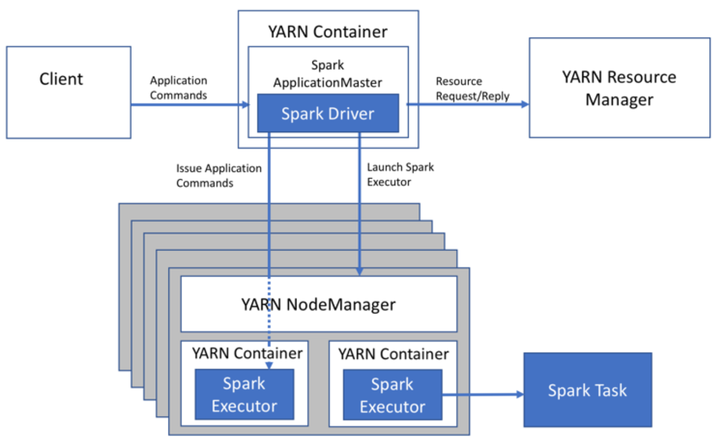

yarn cluster mode

The yarn-cluster mode, however, is not well suited to using Spark interactively. Spark applications that require user input, like spark-shell and PySpark, need the Spark driver to run inside the client process that initiates the Spark application. In yarn-client mode, the Application Master is merely present to request executor containers from YARN. The client communicates with those containers to schedule work after they start:

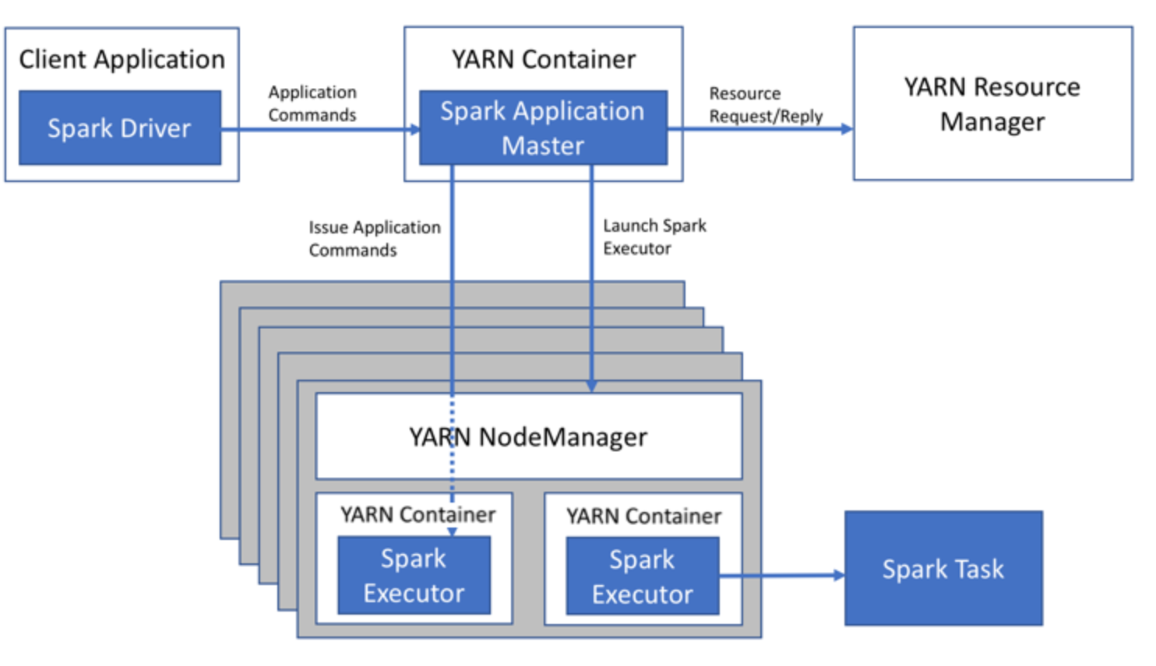

Yarn Client Mode

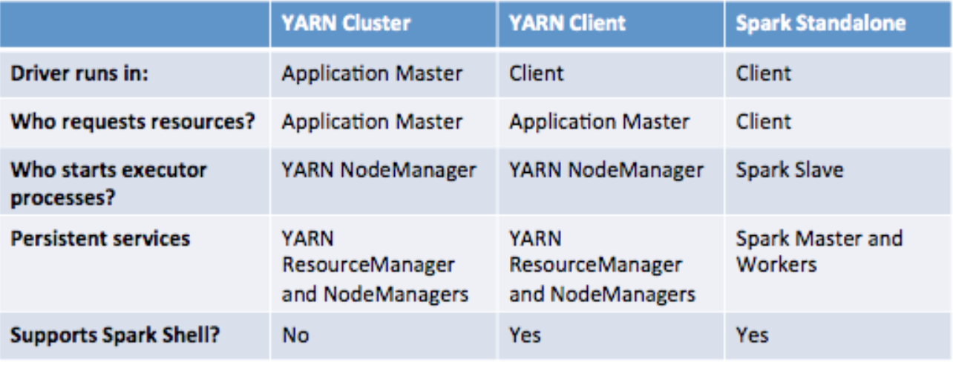

Different Deployment Modes across the cluster

In Yarn Cluster Mode, Spark client will submit spark application to yarn, both Spark Driver and Spark Executor are under the supervision of yarn. In yarn client mode, only the Spark Executor are under the supervision of yarn. The Yarn ApplicationMaster will request resource for just spark executor. The driver program is running in the client process which has nothing to do with yarn.

# Spark Architecture and Deployment Environment

<https://medium.com/@goyalsaurabh66/spark-architecture-and-deployment-f713ac031a88>

A spark application consists of a driver which run either on the client or on application master node and many executors which run across slave nodes in the cluster.

An application can be used for a single batch job, an interactive session with multiple jobs spaced apart, or a long-lived server continually satisfying requests. Unlike MapReduce, an application will have processes, called *Executors*, running on the cluster on its behalf even when it’s not running any jobs. This approach enables data storage in memory for quick access, as well as lightning-fast task startup time.

**Job of Spark Driver**

It is responsible for creating spark context, creating DAG, breaking the job into stages and task and scheduling of the task. It defines the transformations and actions applied to the data set.

At its core, the driver has instantiated an object of the SparkContext class. This object allows the driver to acquire a connection to the cluster, request resources, split the application actions into tasks, and schedule and launch tasks in the executors.

The driver first asks the application master to allocate resources for the containers on the worker/slave nodes and create executors process.

Once the executors are created the driver directly coordinates with the worker nodes and assign the task to them.

https://miro.medium.com/max/60/1*8u3oo-Ko893RZpQbC-aCow.png?q=20

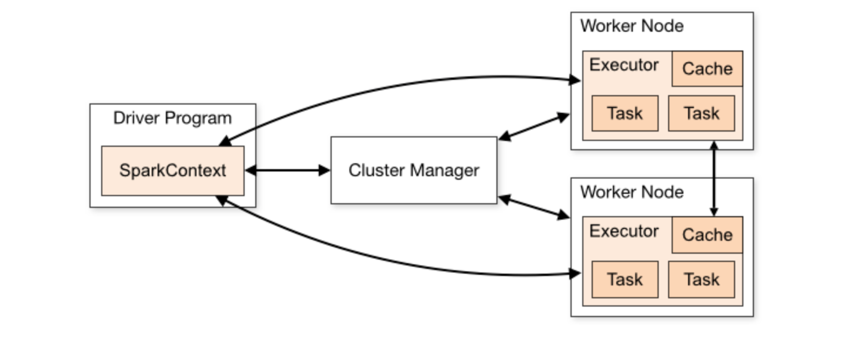

**Job of Executor**

An executor is a JVM process which is responsible for executing the task. many tasks can run in parallel in the executor.

MapReduce runs each task in its own process. When a task completes, the process goes away. In Spark, many tasks can run concurrently in a single process, and this process sticks around for the lifetime of the Spark application, even when no jobs are running.

The advantage of this model, as mentioned above, is speed, Tasks can start up very quickly and process in-memory data. The disadvantage is coarser-grained resource management. As the number of executors for an app is fixed and each executor has a fixed allotment of resources, an app takes up the same amount of resources for the full duration that it’s running. (When YARN supports container resizing, we plan to take advantage of it in Spark to acquire and give back resources dynamically.)

**Cluster Deployment**

The SparkContext can connect to several types of *cluster managers* (either Spark’s own standalone cluster manager, Mesos or YARN), which allocate resources for containers on which spark executors runs.

Spark acquires *executors* on nodes in the cluster, which are processes that run computations and store data for your application. Next, it sends your application code (defined by JAR or Python files passed to SparkContext) to the executors. Finally, SparkContext sends *tasks* to the executors to run.

**Submitting Application (spark-submit)**

The**spark-submit** script in Spark’s bin directory is used to launch applications on a cluster. It can use all of Spark’s supported cluster managers through a uniform interface so you don’t have to configure your application especially for each one.

./bin/spark-submit **\**  
 --class <main-class> **\**  
 --master <master-url> **\**  
 --deploy-mode <deploy-mode> **\**  
 --conf <key>=<value> **\**  
 ... *# other options*  
 <application-jar> **\**  
 [application-arguments

* --deploy-mode: Whether to deploy your driver on the worker nodes (cluster) or locally as an external client (client) (default: client)

if your application is submitted from a machine far from the worker machines (e.g. locally on your laptop), it is common to use cluster mode to minimize network latency between the drivers and the executors.

**Cluster Manager**

**Spark Standalone cluster**

**Standalone Master** is the resource manager for the Spark Standalone cluster

**Standalone Worker** (aka *standalone slave*) is the worker in the Spark Standalone cluster .

Standalone cluster mode is subject to the constraint that only one executor can be allocated on each worker per application.

A client first connects to standalone master and ask for the resources from the standalone master and start the executor process on the worker node and the driver either on the client node itself or in one of the worker node.

Here the client act as the application master which is responsible for requesting the resources from the resource manager/standalone master.

**Hadoop Yarn**

YARN (Yet Another Resource Negotiator) is the resource management layer for the Apache Hadoop ecosystem.

YARN is a software rewrite that decouples MapReduce’s resource management and scheduling capabilities from the data processing component, enabling Hadoop to support more varied processing approaches and a broader array of applications.

The Application Master oversees the full lifecycle of an application, all the way from requesting the needed containers from the Resource Manager to submitting container lease requests to the NodeManager.

Each application framework that’s written for Hadoop must have its own Application Master implementation. Spark also has the implementation of application master.

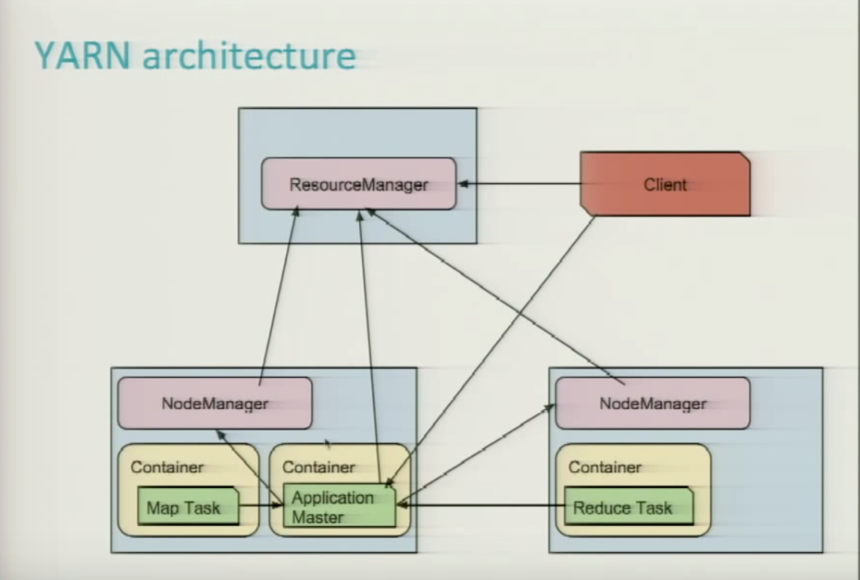

Yarn Architecture

**Yarn Vs Spark Standalone cluster**

* YARN allows you to dynamically share and centrally configure the same pool of cluster resources between all frameworks that run on YARN. You can throw your entire cluster at a MapReduce job, then use some of it on an Impala query and the rest on Spark application, without any changes in configuration.
* Spark standalone mode requires each application to run an executor on every node in the cluster, whereas with YARN, you choose the number of executors to use.